TD/TP 3&4
Objectives: Practice implementing and analyzing searching and sorting algorithms in C++, and apply them to manipulate and organize both numeric and structured data efficiently.
Instructions:
Understand the underlying principles of each exercise and proceed with their implementation using C++ language.
- Interpolation Search
Implement interpolation search — a search algorithm that works efficiently for sorted and uniformly distributed arrays (e.g., where values increase linearly). Then, compare its behavior to binary search.

Binary Search (recall):
Binary search always checks the middle element, regardless of how data values are distributed.
It’s O(log n), very efficient, but does not exploit uniform distribution.
Example: If you search for 95 in [10, 20, 30, ..., 100], binary search jumps around midpoints — it doesn’t know that 95 is near the end.

Interpolation Search (idea):
Interpolation search improves on this by estimating the likely position of the key using linear interpolation (like guessing where the key should be on a number line).
The position is estimated with the formula:
$$\text{pos}=\text{low}+\frac{(key-arr[low])×(high-low)}{arr[high]-arr[low]}$$
This formula behaves like this:
- If key is close to arr[low], pos will be near low.
- If key is close to arr[high], pos will be near high.
- So instead of jumping to the middle, it jumps near the key’s expected position.
Function prototype:
Void interpolationSearch(int arr[], int n, int key);
- Sort a vector of strings (Selection Sort)
Sort an array (or vector) of strings in alphabetical (lexicographic) order using selection sort.
Input: ["banana", "apple", "cherry", "date"]
Output: ["apple ", " banana ", "cherry", "date"]
Selection sort idea (for ascending order):
- For each position i from 0 to n-2, find the smallest string in the subarray arr[i..n-1].
- Swap that smallest string into position i.
- Repeat until the array is sorted.
When comparing strings lexicographically in C++ use std::string::compare or the < operator. The method you suggested:
- arr[j].compare(arr[minIndex]) returns:
  - a negative value if arr[j] < arr[minIndex] (lexicographically earlier),
  - 0 if equal,
  - a positive value if arr[j] > arr[minIndex].
- So to determine if arr[j] comes before arr[minIndex], test arr[j].compare(arr[minIndex]) < 0.
Function prototype:
Void selectionSort(vector<string>& arr);
- Bucket Sort
Implement Bucket Sort to sort floating-point numbers in the range [0, 1) (i.e., real numbers between 0 inclusive and 1 exclusive).
Bucket Sort works best when:
- The input is uniformly distributed over a known range (here [0, 1)).
- We can divide the range into equal subintervals (buckets).
- Each bucket is sorted individually (using, for example, insertion sort).
Then all buckets are concatenated to get the final sorted list.
Algorithm:
Let’s imagine the input:
arr = [0.42, 0,32, 0.23, 0.52, 0.25, 0.47, 0.51]
We create n buckets (for simplicity, the same number as array size).
Each bucket corresponds to a subinterval of [0,1):
- Bucket 0: [0, 0.1)
- Bucket 1: [0.1, 0.2)
- Bucket 2: [0.2, 0.3)
- ...
- Bucket 9: [0.9, 1.0)
Each element arr[i] goes to bucket number:
$$\text{index}=⌊n×arr[i]⌋$$
Then we sort each bucket individually using insertion sort, and finally concatenate all buckets in order.
Function prototype:
Void bucketSort(float arr[], int n); //create n buckets then sort them
Void insertionSort(vector<float>& bucket); //insertion sort for a bucket

- Mini Project (Sort Structure by Multiple Fields)
Goal:
Work with structured data representing computer products, and sort them according to specific criteria.
(P.S.: This work will be evaluated during the TP session.)
To do:
- We define a structure to represent a product: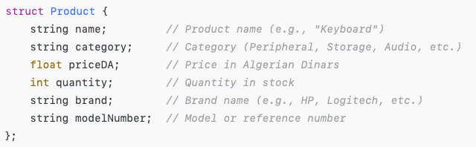
So, each Product groups related attributes of an item together.
- Sort by Price (Ascending), then Quantity (Descending):
Write a function to sort a vector of Product objects according to:
- Price (ascending)
- If prices are equal → Quantity (descending). (When two products have the same price (e.g., Keyboard and Headset), the one with higher stock quantity comes first.)
So, the comparison logic is:
- if (price1 < price2) → product1 comes first
- if (price1 == price2 && quantity1 > quantity2) → product1 comes first
Use quick Sort algorithm.
Function prototype:
Void quickSortProductsPriceA_QuantityD(float arr[], int n);
- Overwrite the sorting function (Sort a vector of strings -- defined in part B)
Reuse the same function defined in part B selectionSort(vector<string>& arr), but change its parameter type to sort a vector of products by name or model number.
- Part B version: selectionSort(vector<string>& arr) → sorts simple strings (e.g., names).
- New version: selectionSortProductsByNameOrModel(vector<Product>& product, string criterion) → This version sorts products either by name or by model number based on criterion value ("name" or "modelNumber") that defines the sorting key.
Guide:
Fill the product vector in the int main as follows:
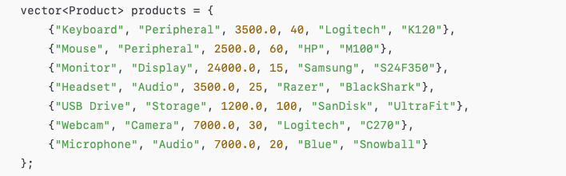
Use this display function to show the sorted results.
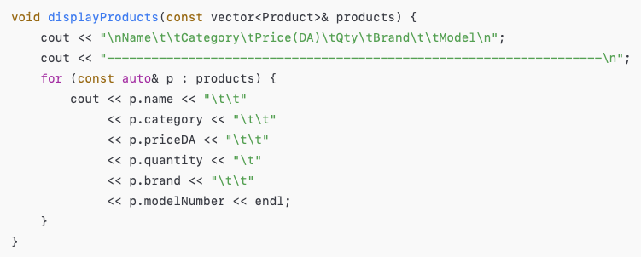
Output Example
Before Sorting:
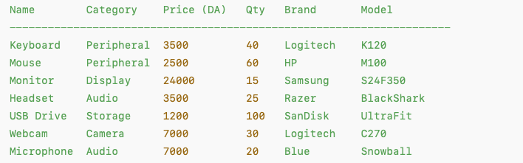
After Sorting (Price ↑, Quantity ↓):
